**How to pull new materials from your instructor repo.**(This is typically done each morning before class to pull in the starter lecture code and exercises and usually again in after class after I check in the final lecture code)

1. Navigate to your **individual student repository** using the repos shortcut (found on desktop or File Explorer), or navigate directly to: ***C:\Users\Student\source\repos\individual/yourname-student-code***  
   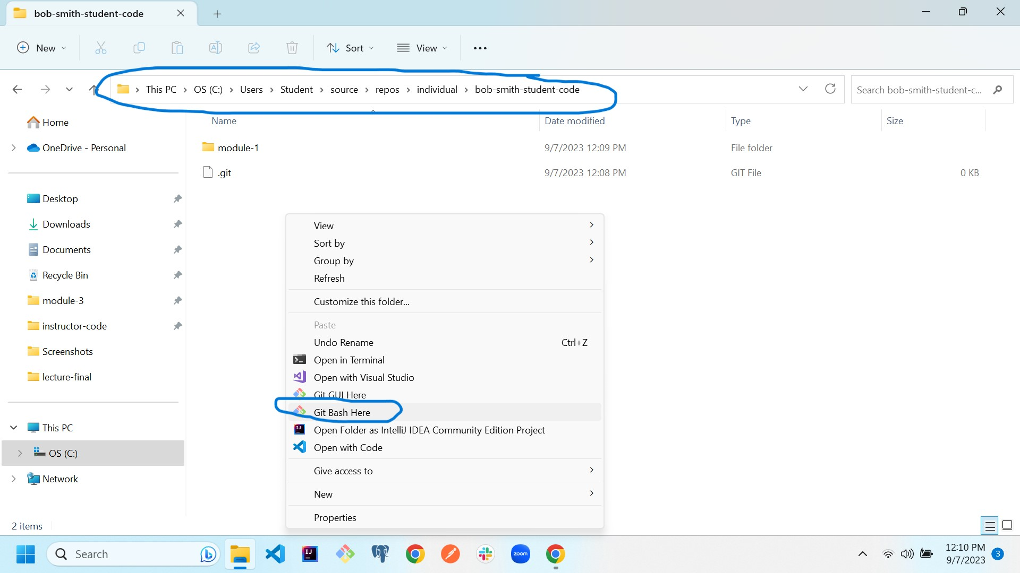
2. Right-Click in the open area and select: **Git Bash Here.** This will open git bash in the proper directory. **You must be inside your-name-student-code directory for git commands to work.**

**Run the following commands in order.**

1. $ git add -A
2. $ git commit -m “your comment”
3. $ git pull **upstream** main

***upstream*** is the alias for the instructor repo. If there is material in the instructor’s repo that you don’t have, it will be pulled into yours. Always do an add and commit prior to doing a pull from upstream.   
  
**NEVER delete your local code and try to re-pull from my repo. It will not work. (Once you pull, your code is the most recent and it will not allow you to pull older versions from my repo. You need to fix your local code, or see an instructor for assistance)**  
Watch for errors after each step. See an instructor if you need help.